kk
S.No | Name | Designation | Nature | Approvals | appointment date | Photo
1 | Dr. Sumeer Sharma | Principal | Regular | (Approved by University) | 01/10/2016 | 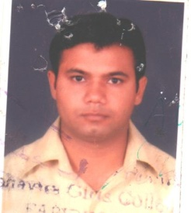
2 | Mr. Puneet Kumar | Asst. Prof. | Regular | (Approved by University) | 01/09/2016
3 | Ms. Rajni | Asst. Prof. | Regular | (Approved by University) | 02/03/2019 | 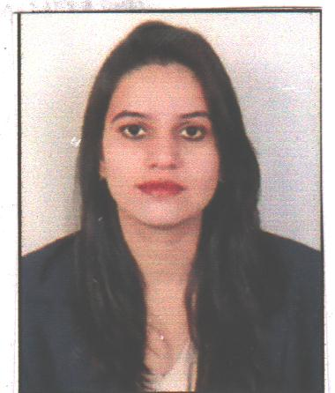
4 | Ms. Aastha Khichi | Asst. Prof. | Regular | (Approved by University) | 02/03/2019
5 | Ms.Jaspreet Kaur | Asst. Prof. | Regular | (Approved by University) | 02/03/2019 | 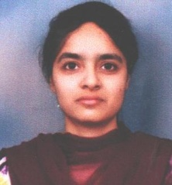
6 | Mr. Punit | Asst. Prof. | Regular | (Approved by University) | 02/03/2019
7 | Mr. Shaminder Singh | Asst. Prof. | Regular | (Approved by University) | 02/03/2019 | 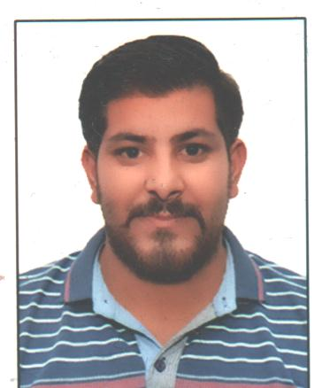
8 | Ms. Rashi | Asst. Prof. | Regular | (Approved by University) | 02/03/2019
9 | Ms. Shikha | Asst. Prof. | Regular | Approval Under process in university | 01/05/2017 | 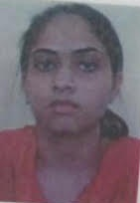
10 | Mr. Mahesh Kumar | Asst. Prof. | Regular | Approval Under process in university | 01/09/2016
11 | Ms. Gouri Sachdeva | Asst. Prof. | Regular | Approval Under process in university | 01/09/2016
12 | Ms Sumanpreet | Asst. Prof. | Regular | Approval Under process in university | 21/07/2017
13 | Ms. Gagandeep Kaur | Asst. Prof. | Regular | Approval Under process in university | 21/07/2017
14 | Ms Anju | Asst. Prof. | Regular | Approval Under process in university | 21/07/2017 | 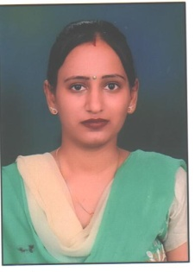
15 | Ms. Payal | Asst. Prof. | Regular | Appointed Through Management | 12/07/2018
16 | Manpreet Singh | Asst. Prof. | Regular | Appointed Through Management | 01/09/2016 | 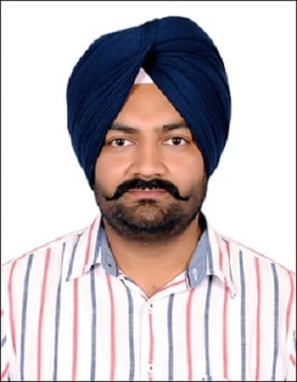
17 | Ms. Rajwinder Kaur | Asst. Prof. | Regular | Appointed Through Management | 01/09/2016

D.El.Ed

1 | Mr.Ruffi | Asst. Prof. | Regular | Appointed Through Management | 10/10/2016 | 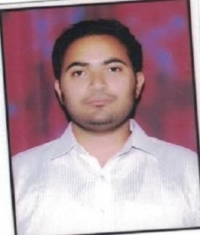
2 | Ms. Nishu | Asst. Prof. | Regular | Appointed Through Management | 16/07/2018
3 | Ms. Sukhpreet Kaur | Asst. Prof. | Regular | Appointed Through Management | 10/07/2017
4 | Ms. Rajbir Kaur | Asst. Prof. | Regular | Appointed Through Management | 10/10/2016
5 | Ms. Amandeep Kaur | Asst. Prof. | Regular | Appointed Through Management | 03/09/2018
6 | Mr. Amandeep Singh | Asst. Prof. | Regular | Appointed Through Management | 03/09/2018

Non Teaching Staff

1. | Mr. Sandeep Singh | office superintendent | Regular | Appointed Through Management | 24/08/2017
2. | Mr. Pushkar | Accountant | Regular | Appointed Through Management | 01/10/2016
3. | Mr. Ramesh | Superviser | Regular | Appointed Through Management | 01/10/2016
4. | Ms. Rupinder Kaur | Receptionist | Regular | Appointed Through Management | 12/10/2017

